Welcome to your project!

* Brush up on Markdown: <http://daringfireball.net/projects/markdown/basics>
* Learn about Penflip: [penflip.com/help](http://www.penflip.com/help)
* Talk to a person: [support@penflip.com](mailto:support@penflip.com)

## SHS Senior seeks sponsors for trip to 4H Nationals Shooting Sports Championship

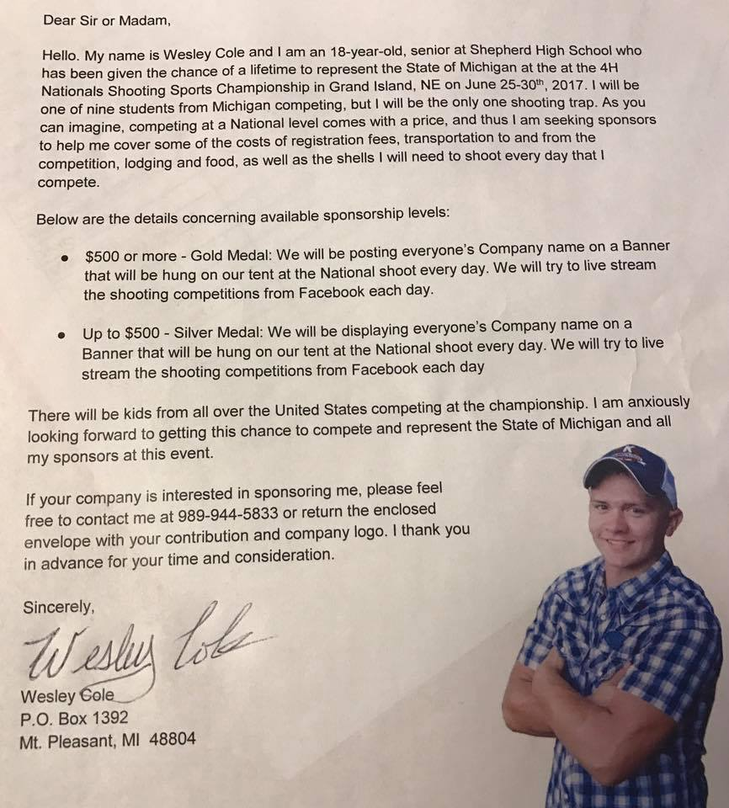

Jay Gross passed along a note from Shepherd High School senior Wesley Cole asking for support for his trip to the 4H Nationals Shooting Sports Championship.

Hey There Shepherd…  
Wesley Cole is going to shoot at Nationals!  
He is looking for some help to get there…  
Please think about a possible donation or please share.  
He is the only one from Michigan shooting trap and has a GREAT shot at winning it all!

In the letter, Wesley writes:

Hello. My name is Wesley Cole and I am a 18-year-old, senior at Shepherd High School who has been given the chance of a lifetime to represent the State of Michigan at the 4H Nationals Shooting Sports Championship in Grand Island, NE on June 25-30 2017. I will be one of nine students from Michigan competing, but I will be the only one shooting trap. As you can imagine, competing at a National level comes with a price, and thus I am seeking sponsors to help me cover some of the costs.

Among the costs are:

* registration fees
* transportation to and from the competition
* lodging and food
* shotgun shells

He describes two sponsorship levels:

* $500 or more - Gold Medal
* Up to $500 - Silver Medal

Wesley says that sponsors’ names or logos will be displayed on a banner that will be displayed during the competition. He also mentioned plans to live stream the competition on Facebook.

More details are included in the letter (see the image included above). If you would like to contact Wesley, his phone number is (989) 944-5833.